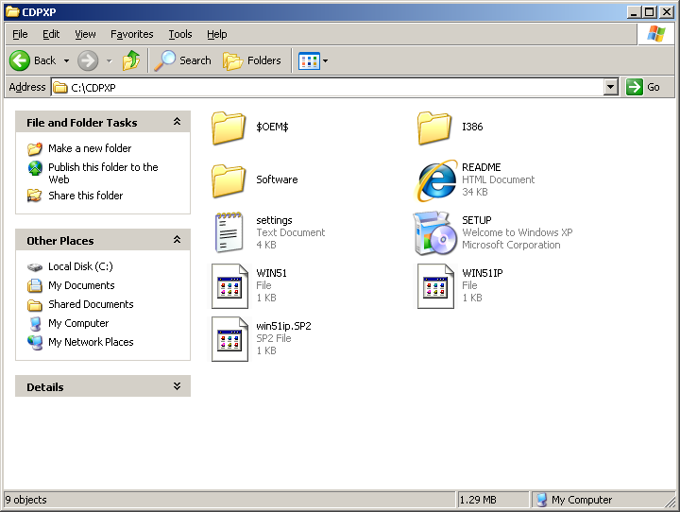

Should I remove this one too?
And create ISO and install it

